ECMWF OSES for long time scales: reanalysis and seasonal forecasts

Magdalena A. Balmaseda, Hao Zuo, Eric de Boisseson, Kristian Mogensen, Alison Cobb

Here we present results from the ECMWF contribution to SynObs related with the impact of the ocean observations on long time scales, including ocean reanalysis and seasonal forecasts. A series of Observing System Experiments (OSEs) have been conducted with the most recent version of the ECMWF ocean reanalysis (ORA) and seasonal forecast. In the experiments, one or several observing systems are withheld from ocean reanalysis spanning the period 2001-2023. The ocean reanalysis OSES are then used to initialize a series of seasonal reforecasts (May and November start) spanning the same period. Results show that the insitu observations have a profound impact on the ocean state estimation, being indeed are essential in order to exploit satellite observations such as SST and altimeter sea level. The ocean observations also affect the quality of the seasonal forecasts one and two seasons ahead. The tropical Atlantic is an area that appears quite sensitive to the use of ocean observations, where results indicate that there is room for further improvements in data assimilation methods.

Possible figures for DG Report

Fig 1. Top) impact of insitu ocean observations on seasonal forecasts of MSLP. Bottom) impact on bias of atmospheric (left) and ocean (right) variables on subseasonal forecasts.

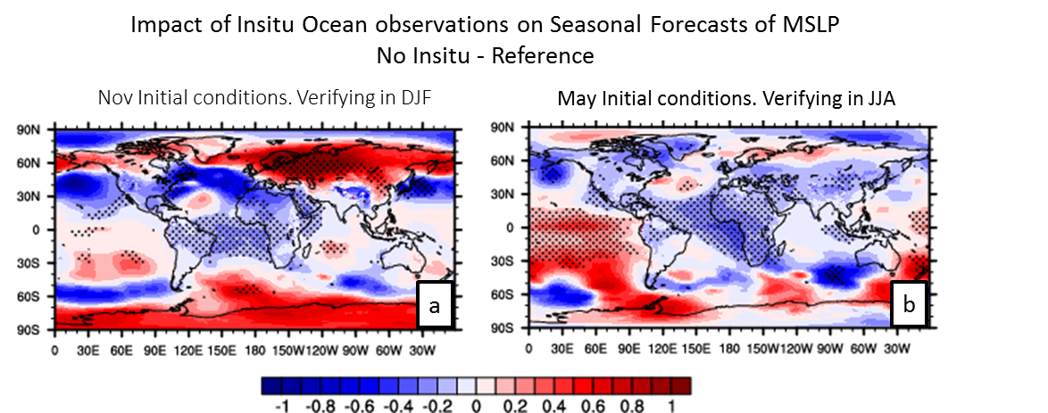

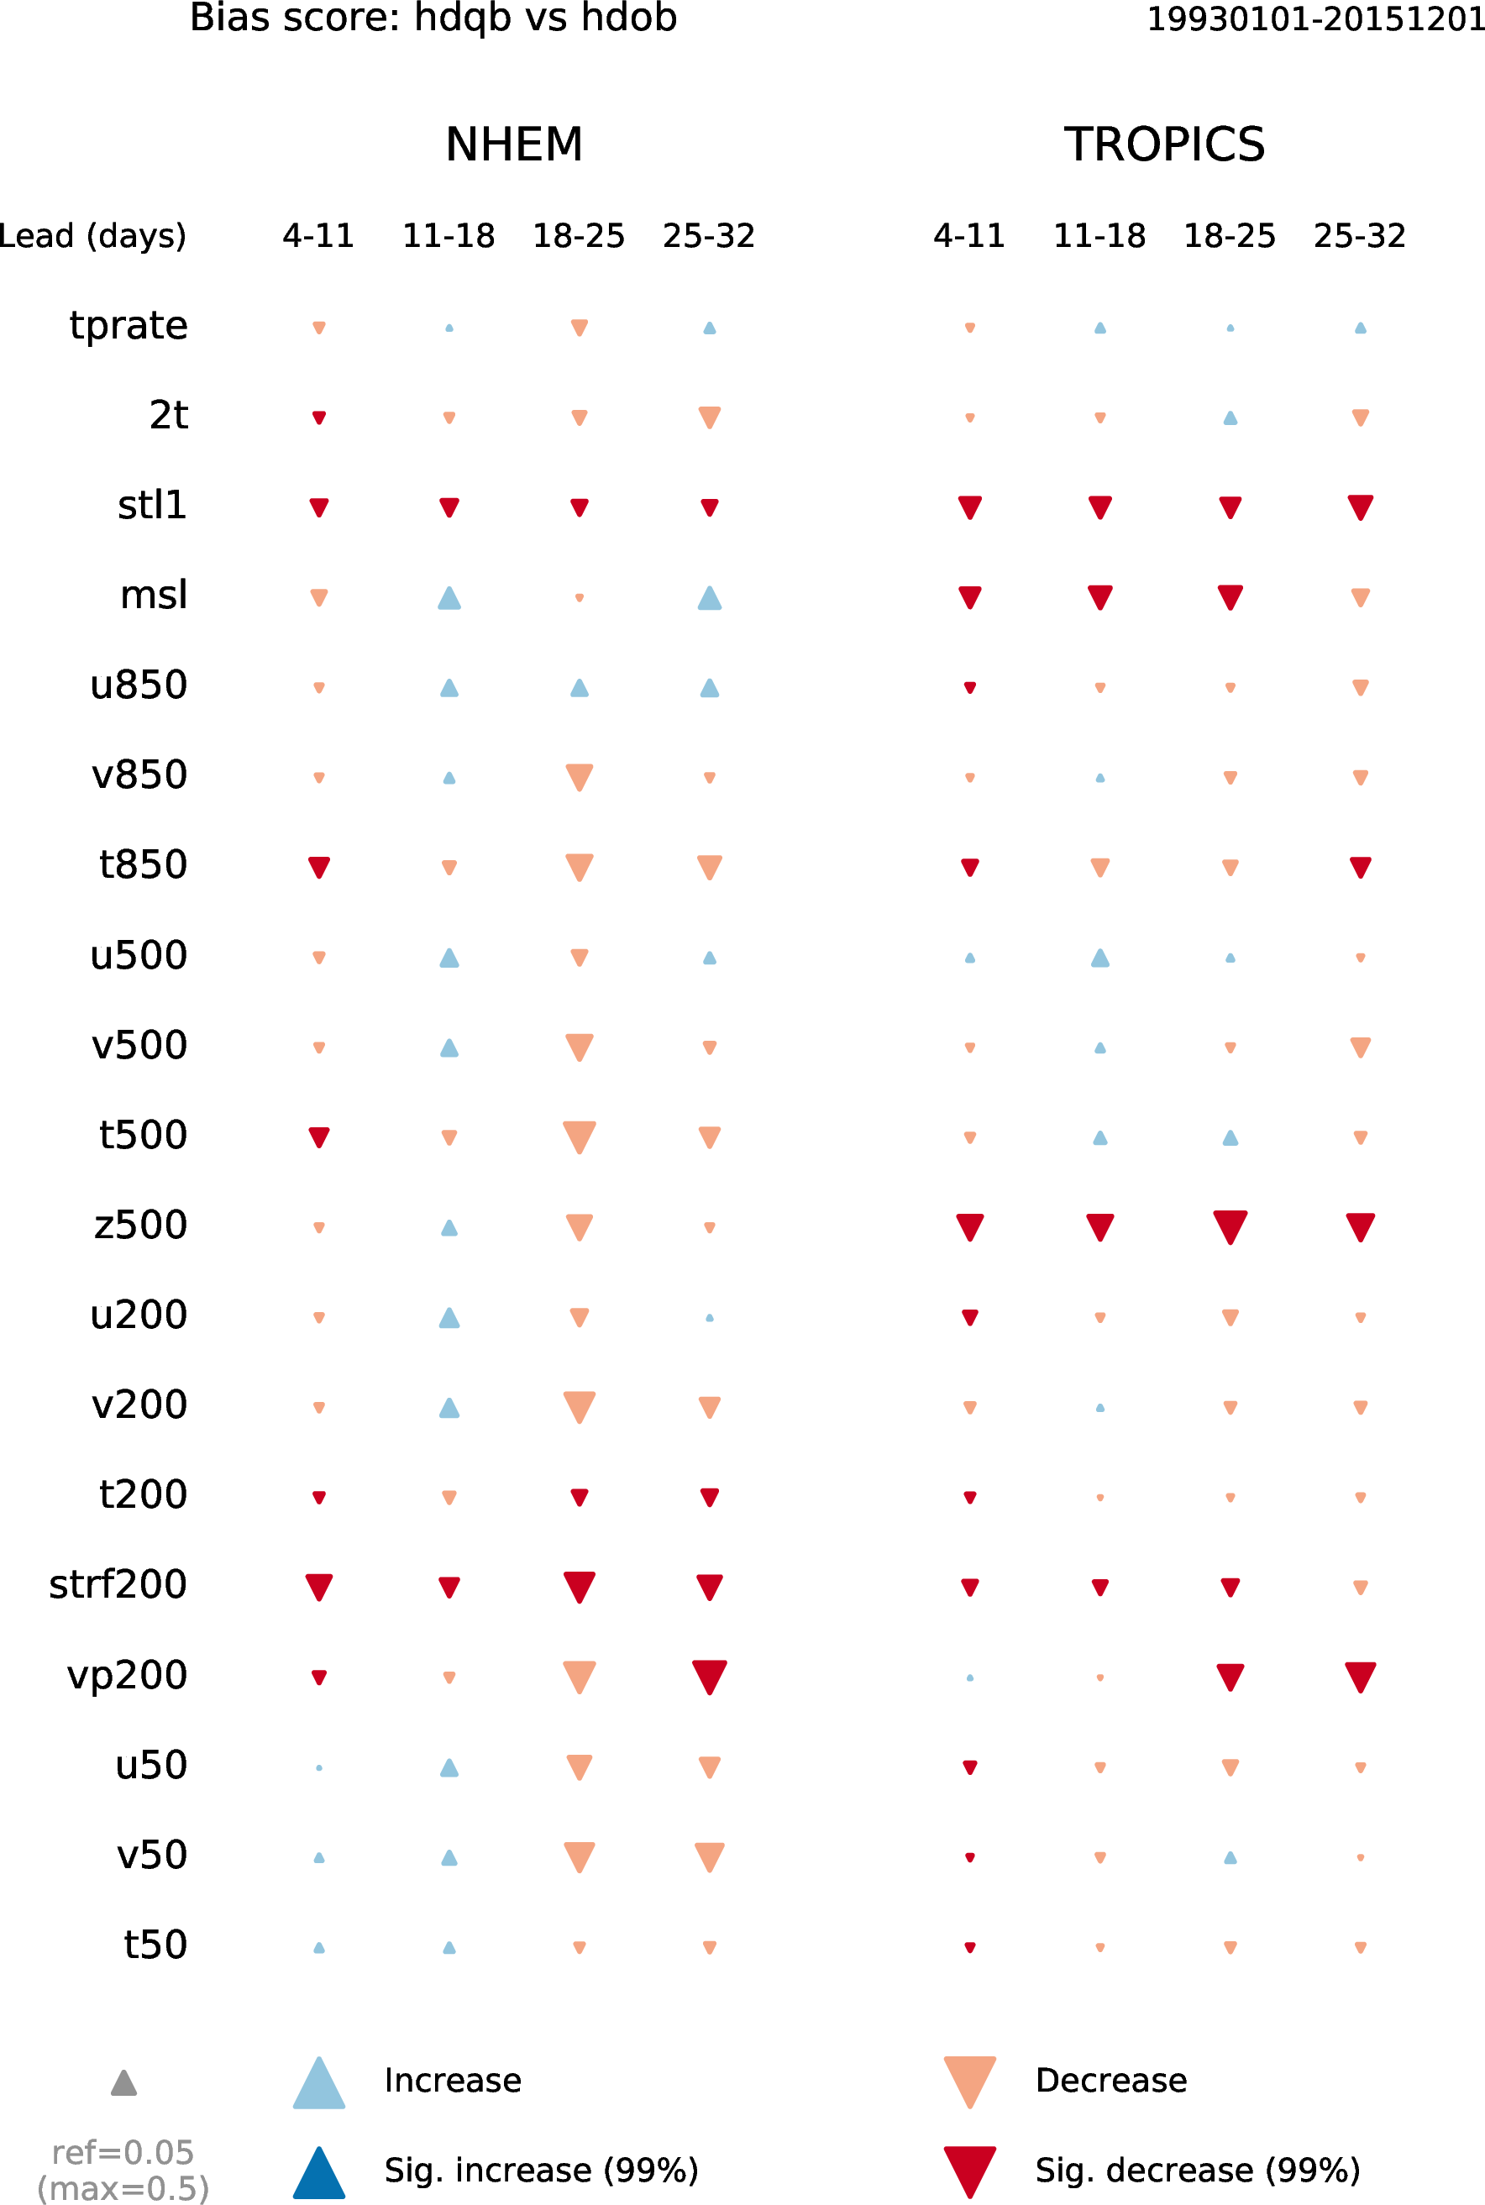
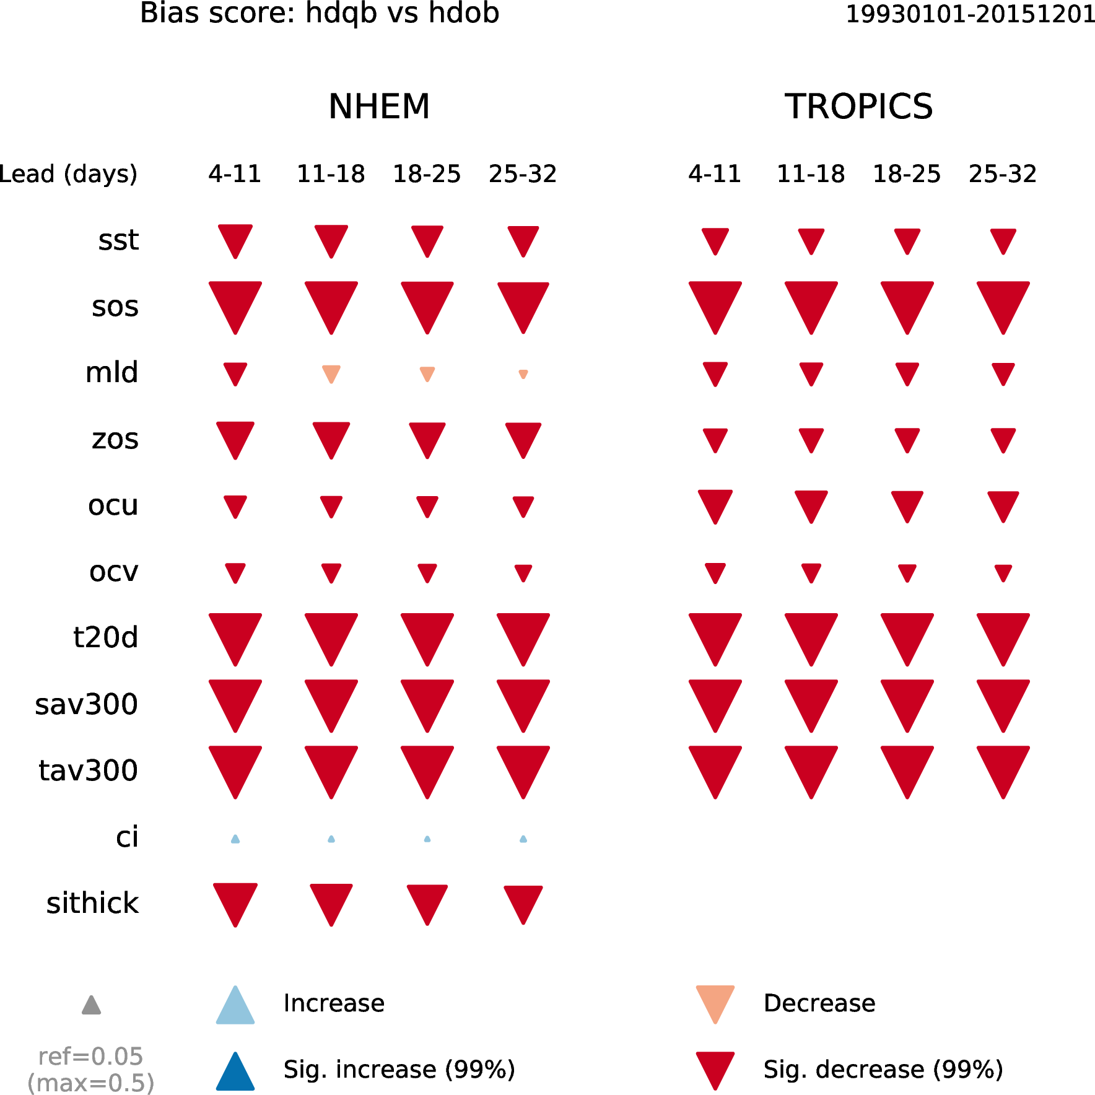
Red : Degraded mean state
Atmosphere: NoInsitu-Ref Ocean: NoInsitu-Ref

